

EUROPEAN CONFERENCE ON
HIGHER EDUCATION:
TRAINEESHIPS & MOBILITY CONSORTIA

Bilbao, 27 – 28 October 2014

http://www.ikaslangipuzkoa.net/es/european-conference

CONFERENCE VENUE: Bizkaia Aretoa (Auditorium: Baroja)

Universidad del País Vasco – Euskal Herriko Unibertsitatea

Avenida Abandoibarra, 3 (BILBAO)

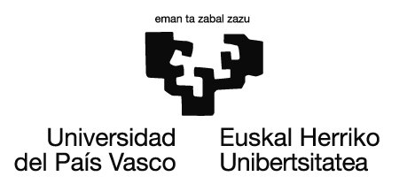
Partners:
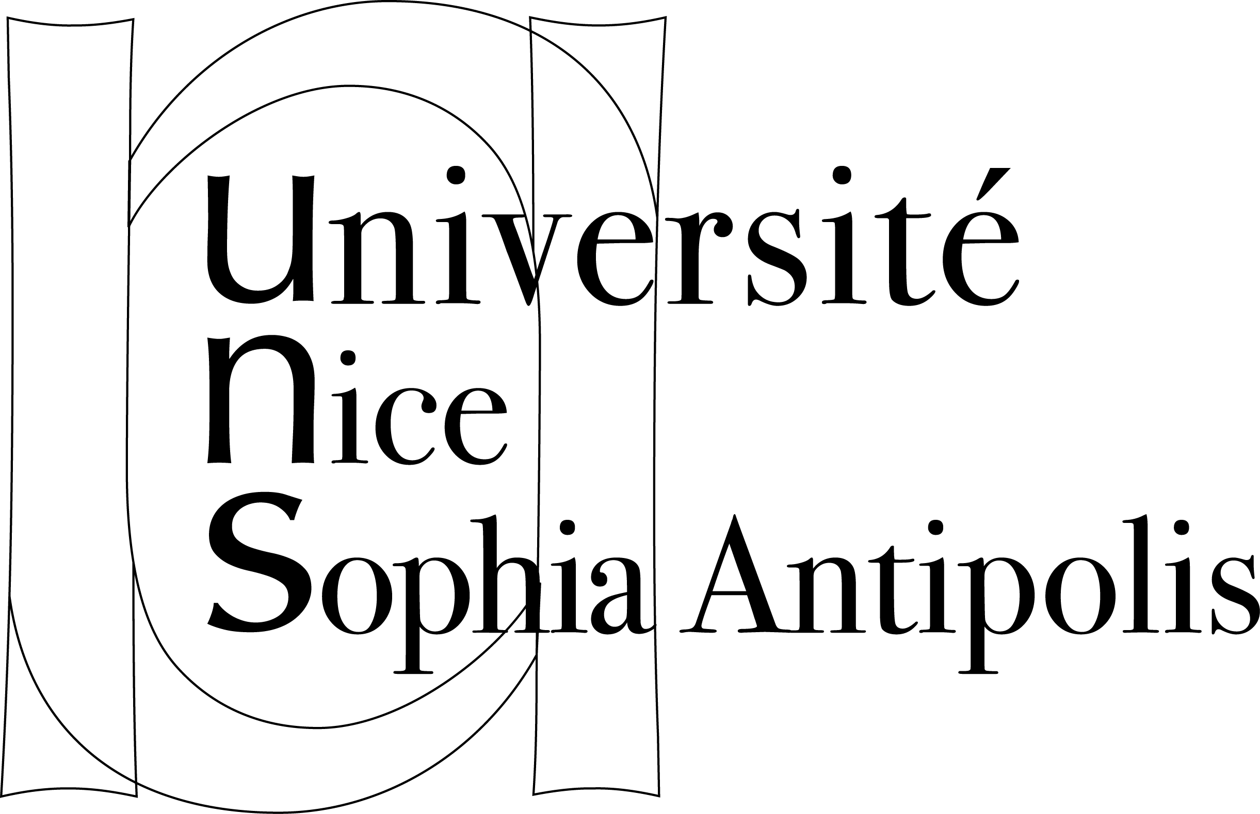
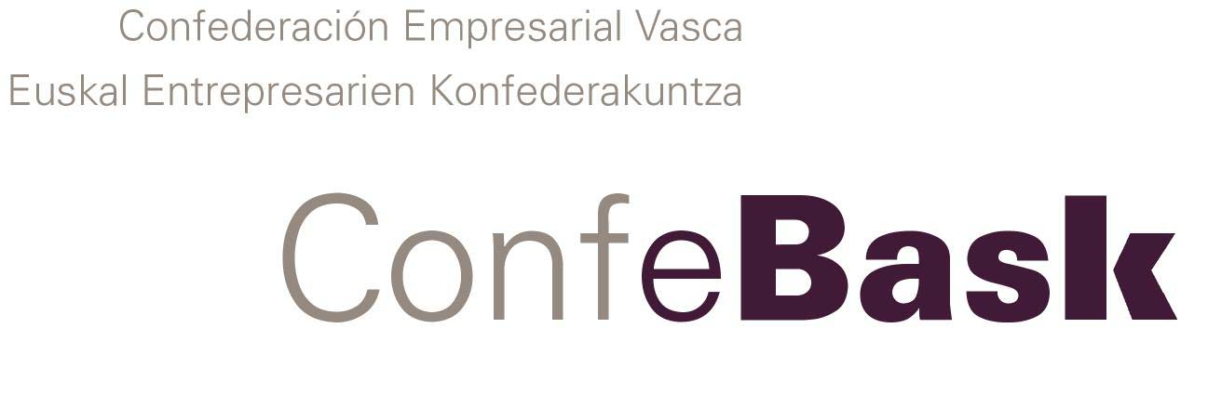
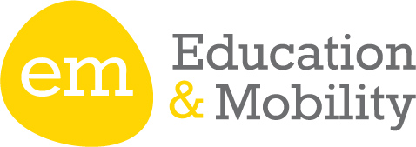

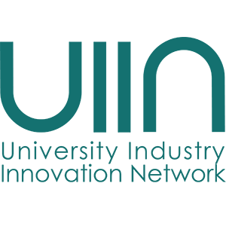
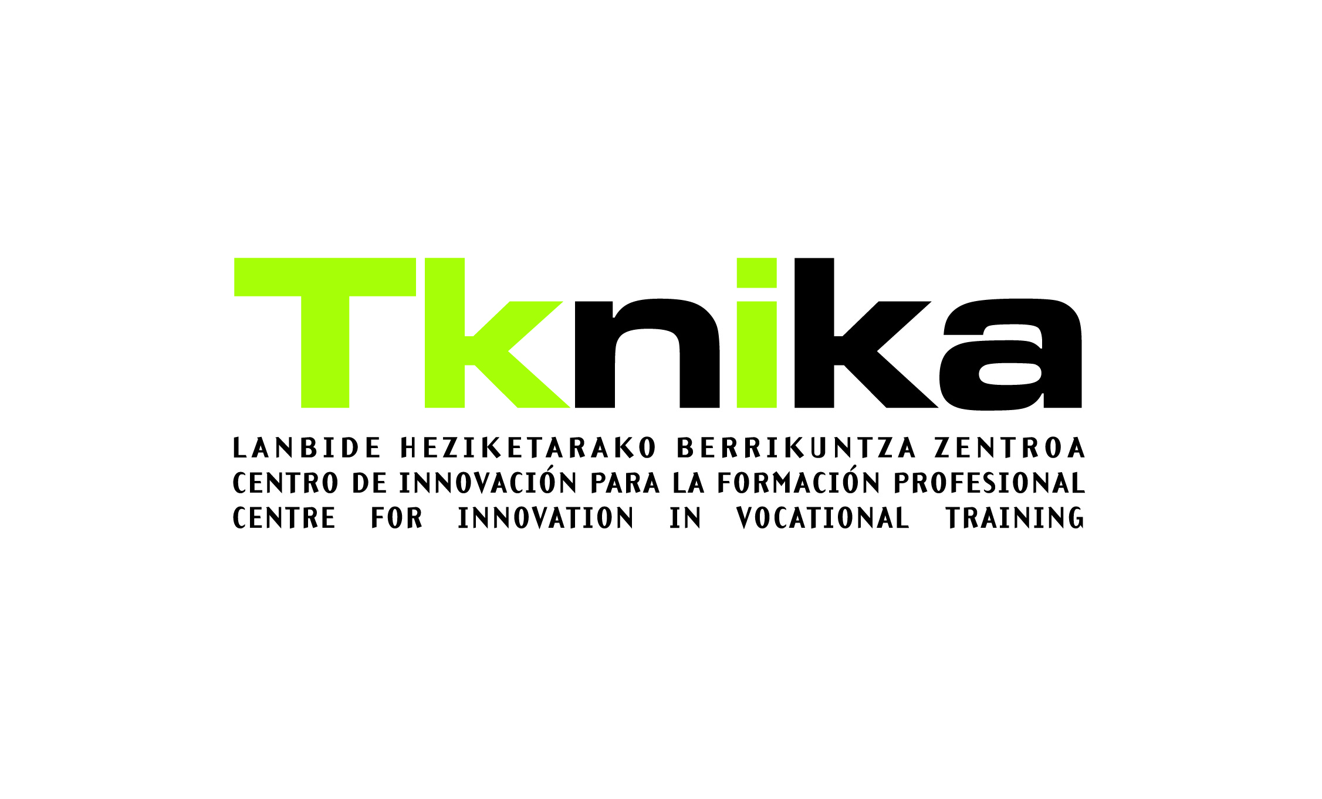

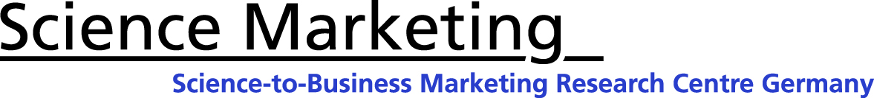
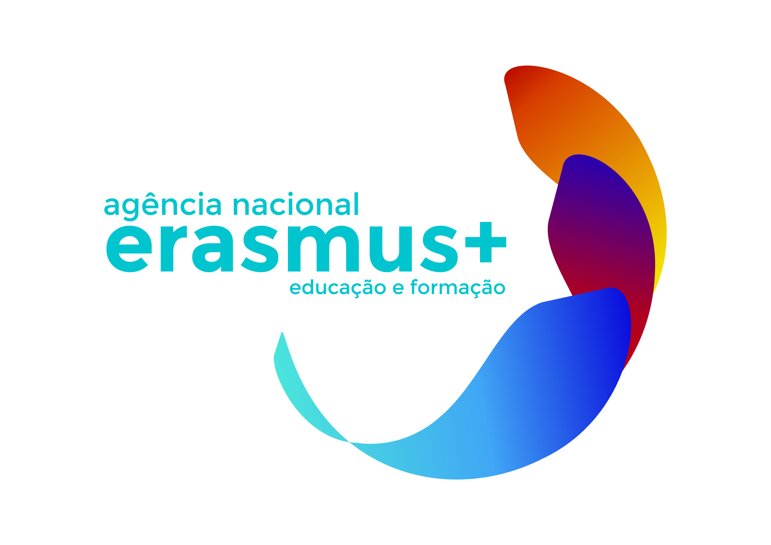
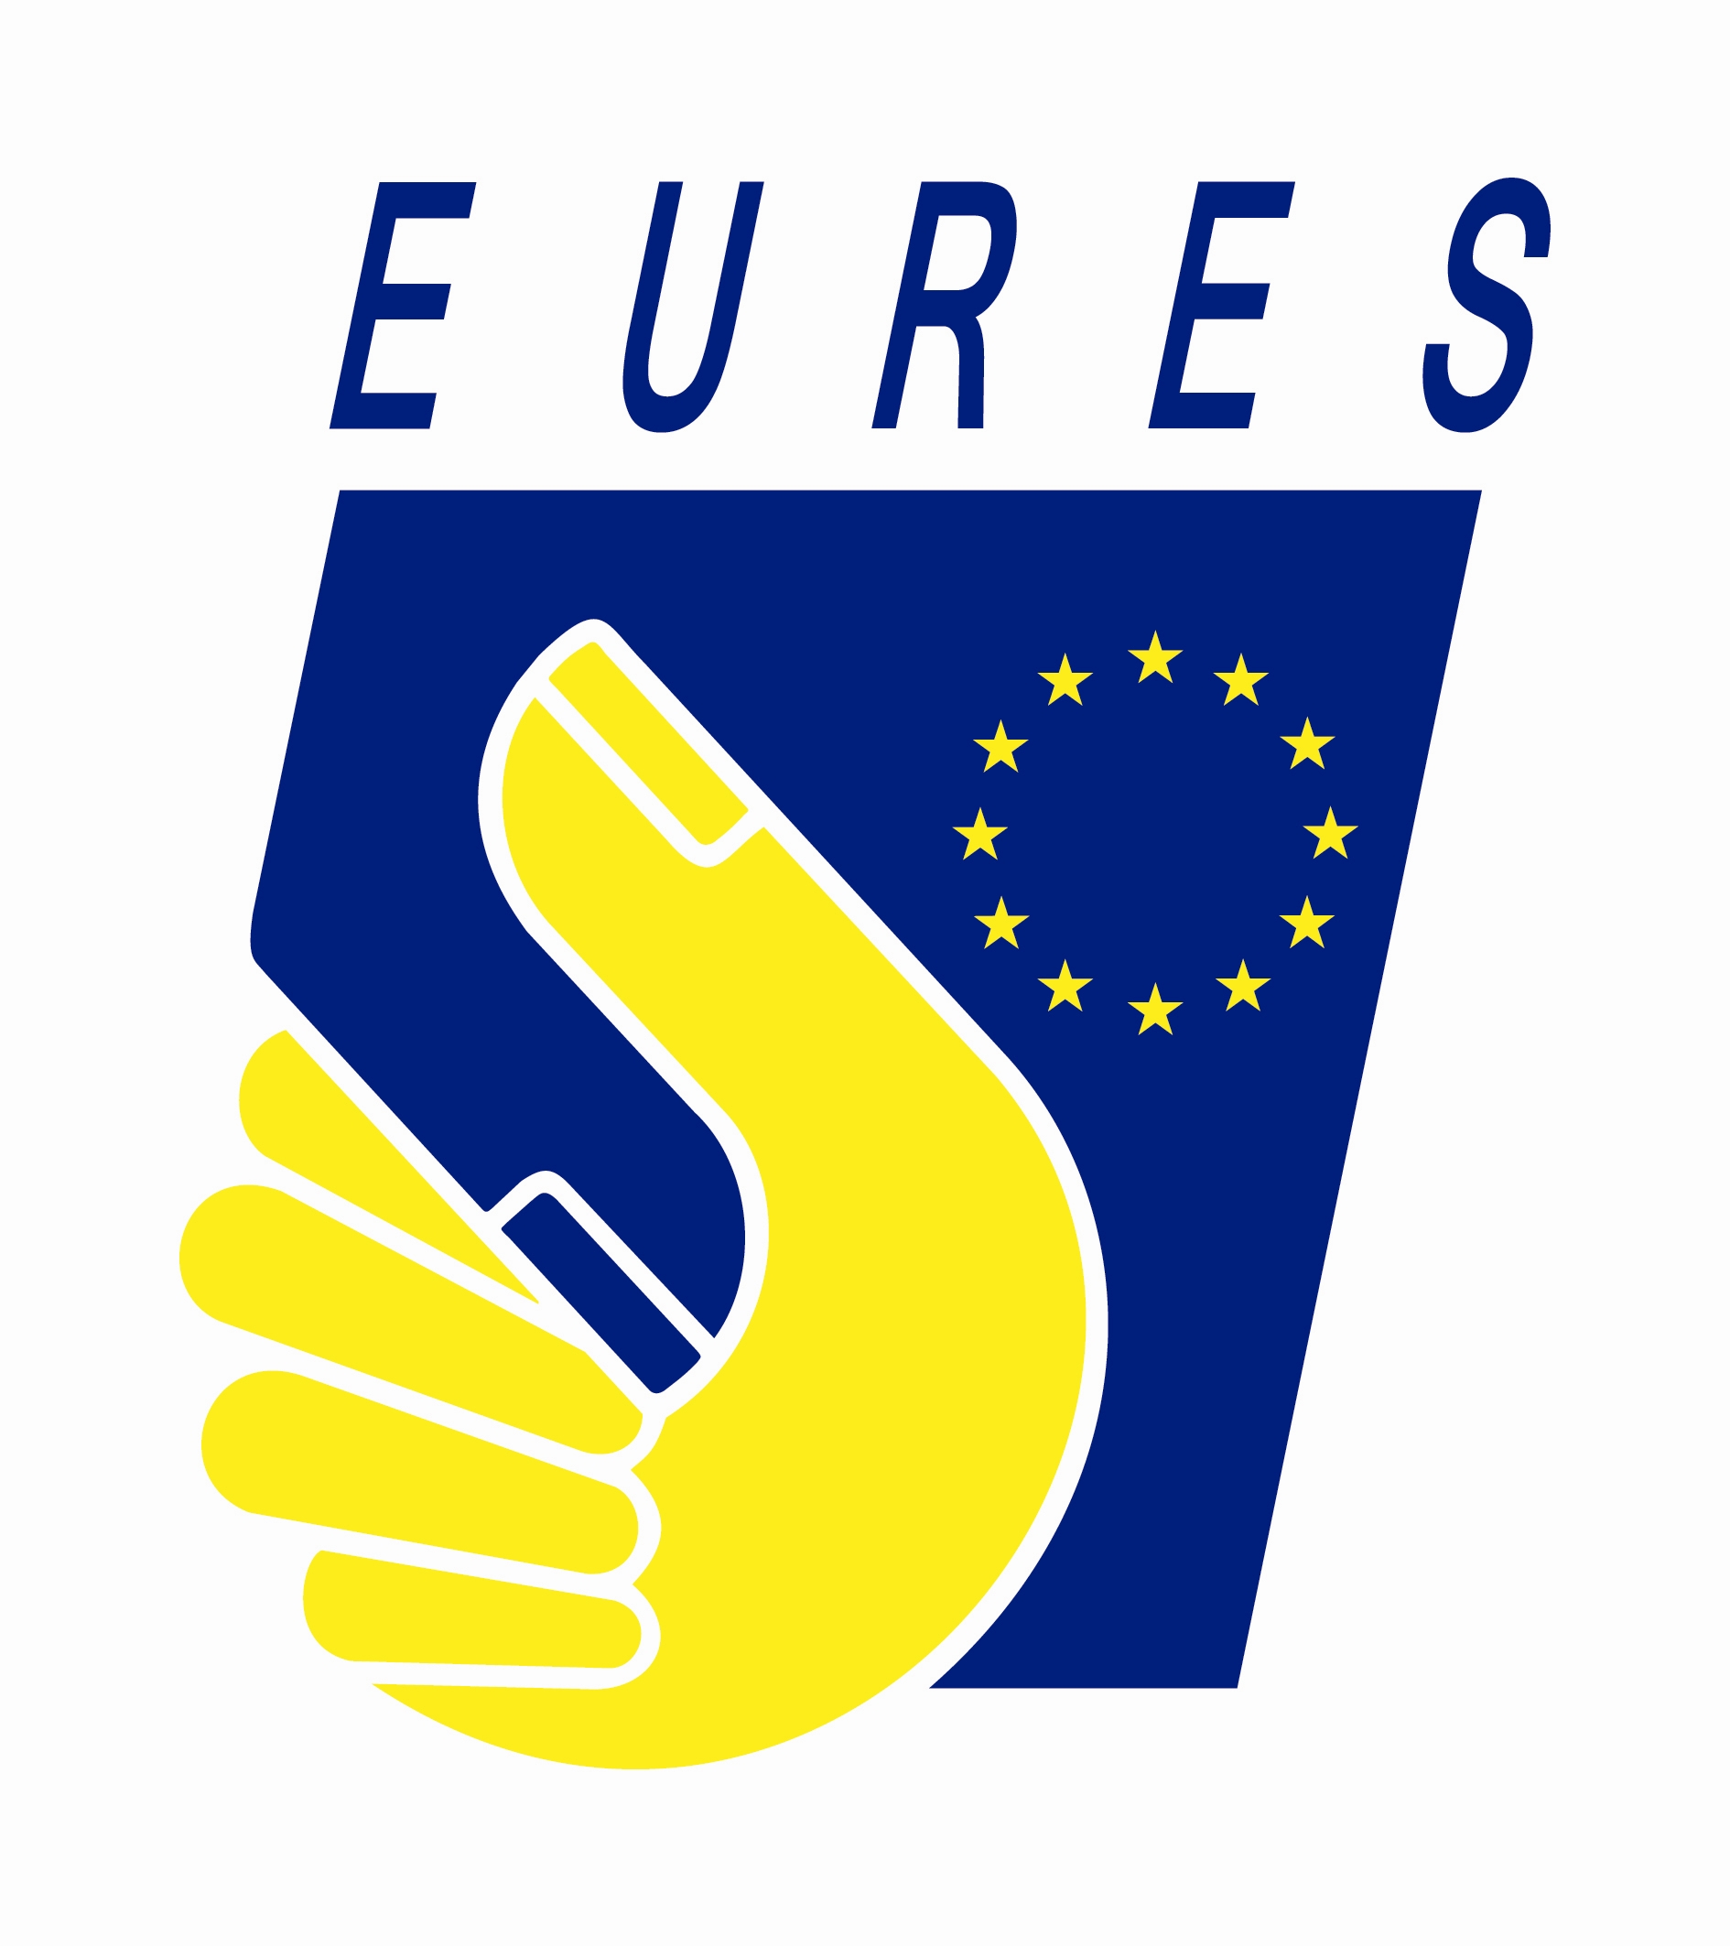


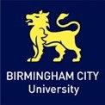

Monday, 27 October 2014
10:00 – 11:00 REGISTRATION
11:00 – 11:30 Opening and welcome speeches
Ms. Nekane Balluerka
Vicerrectora de Estudios de Posgrado y Relaciones Internacionales
Universidad del País Vasco – Euskal Herriko Unibertsitatea

Mr. Ramon Martinez de Murguia Director for Training and Learning.
Department of Education, Language Policy and Culture. Basque Government

Mr. Javier Alonso Aldama
Director for Universities.
Department of Education, Language Policy and Culture. Basque Government

Mr. Juan Carlos Parodi Román. Head of Higher Education Unit - OAPEE (Spanish National Agency)
Mr. Sergio Fidalgo Erasmus+ International Project Coordinator, IKASLAN
Mobility actions in Erasmus + Chairwoman: Marisa Martín, Higher Education Unit. Spanish National Agency
11:30 – 11:50 Participation of mobility consortia in Higher Education in 1st call of Erasmus+ Vanessa Debiais-Sainton - European Commission
1) 27.10.14-A1-VANESSA_DEBIAIS
11:50 – 12:20 The role of mobility Consortia in Higher Education in Spain
Juan Carlos Parodi, Head of Higher Education Unit – OAPEE - Spanish NA
1) 27.10.14-A2-JCARLOS_PARODI
12:20 – 12:45 Erasmus STORY project Marta Guasp – Erasmus Student Network – ESN Spain
1) 27.10.14-A3-MARTA_GUASP
12:45 – 13:15 Erasmus Impact Study Vanessa Debiais-Sainton - European Commission
1) 27.10.14-A4-VANESSA_DEBIAIS
13:15 –14:50 Lunch

Higher Education and Business Cooperation Chairman: Mr. Javier Alonso Aldama
Director for Universities. Basque Government
14:50 – 15:20 HEIs – Business Cooperation: Ecosystem Arno Meerman, CEO of UIIN & Business Development Manager at the Science-to-Business Marketing Research Centre
1) 27.10.14-B1-ARNO_MEERMAN
15:20 – 15:30 Work-based Learning Jose Lara, Unit of Higher Education. Spanish National Agency
1) 27.10.14-B2-JOSE_LARA
15:30 – 16:30 Hunting for traineeships The Company point of view DANOBATGROUP
The Consortium point of view Arantza Vigiola, Representative of Confebask Mobility Consortium
1) 27.10.14-B4-ARANTZA_VIGIOLA
Sergio Fidalgo, Coordinator IKASLAN Mobility Consortium
1) 27.10.14-B5-SERGIO_FIDALGO

16:30 Cultural Programme
27.10.14-C-Cultural Programme

20:30 DINNER AT HOTEL ERCILLA

Tuesday, 28 October 2014
Employability Chairwoman: Irene García, Erasmus + Project Manager - IKASLAN
09:30 – 10:00 Employability and Higher Education: What it is / what it is not Sonia Hendy-Isaac, Birmingham City University, UK
1) 28.10.14-1-SONIA_HENDY
10:00 – 10:30 Employers feedback on important elements and competencies Carlos Sardá, Unilever – Spain
10:30 – 11:00 Added value of Erasmus + Traineeships Eva Touriño – Eures Jaén – Spain
1)28.10.14-3-EVA_TOURINO
11:00 – 11:30 Coffee Break
Enhancing the quality of traineeships Chairman: Rubén Durán, Higher Education Unit. Spanish National Agency
11:30 – 11:50 Chances and challenges for current and future mobility Consortia in Higher Education Maria João Dornelas. Unit of Higher Education. Portuguese National Agency
1) 28.10.14-4-MJOAO_DORNELAS
11:50 – 12:15 Erasmus traineeships Consortium in southern Italy, from past to future Dr. Franca Leonora Morrone, University of Calabria – Italy
1) 28.10.14-5-FLEONORA_,MORRONE
12:15 – 12:40 Centre for Innovation – Tknika Bittor Arias – Tknika
1) 28.10.14-6-BITTOR_ARIAS
12:40 – 13:40 Round Table Quality framework for traineeships in Erasmus + Chair: Jose Manuel González Canino, Higher Education Unit - OAPEE Philippe Gourbesville, Director Polytech Nice Sophia - French CONSORTIUM Iker Orueta, Education & Mobility Mary May, Erasmus+ National Agency - Ireland
Llanos Verdú, Johnson & Johnson – Spain
28.10.14-7-ROUND_TABLE

14:00 Lunch

